COMP2007 Assignment 4 Report

Jiashu Wu 460108049 jiwu0083

# Question 1

## Formulate the problem as a network flow problem

I will illustrate this Max Flow Algorithm using the following flow network.

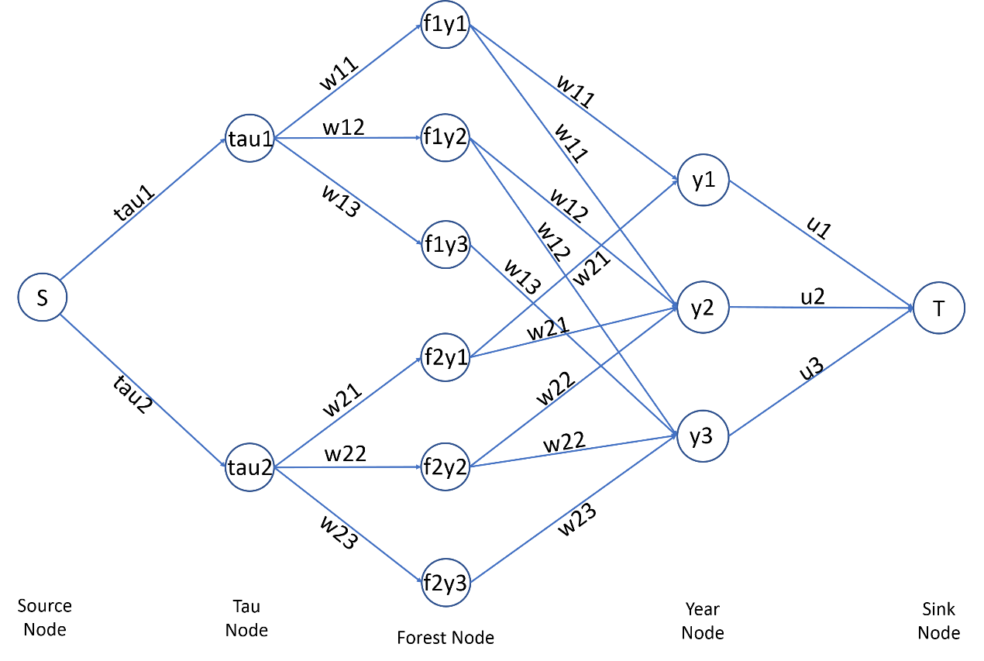

**Note:**

1. In the flow network above, S is the source, and T is the sink.
2. In the flow network above, fiyj stands for node forest i year j.
3. Since delta1 = 2, all the trees matured in the Year 1 can only be sold during Year 1 and Year 2. Hence, forest nodes f1y1 and f2y1 are connected to year node y1 and y2.
4. Since delta2 = 2, all the trees matured in the Year 2 can only be sold during Year 2 and Year 3. Hence, forest nodes f1y2 and f2y2 are connected to year node y2 and y3.
5. Since delta3 = 1, all the trees matured in the Year 3 can only be sold during Year 3. Hence, forest nodes of f1y3 and f2y3 are connected to year node y3.

## Argue the correctness of the algorithm

**Note**: The following theorem and properties will be used.

Integrality Theorem: If all capacities are integers, then there exists a max flow f for which every flow value f(e) is an integer.

Capacity Property of S-T flow: The flow value through edge e will not exceed the capacity of edge e and will greater than or equal to zero, i.e. 0≤f(e)≤c(e).

Conservation Property of S-T flow: For all nodes v except source node and sink node, the total value of incoming flows is equal to the total value of outgoing flows.

In the flow network constructed above, firstly, the edge between source node S and tau node tau1 and tau2 has capacity tau1 and tau2 respectively, which corresponds to the constraint that for each forest i the total number of trees sold in all Y years shouldn’t exceed taui . Secondly, All edges between tau node taui and forest node fiyj and all edges between forest node fiyj and year nodes have capacity wi,j , which correspond to the constraint that at year j, forest i will have wi,j number of trees become matured. Thirdly, all the forest nodes fiyj are connected to year node from yj to y(j + deltaj - 1), which correspond to the constraint that for trees matured in year j, it can only be sold from year j to year (j + deltaj - 1), and fourthly, all edges between year node yi and sink node T have capacity ui , which corresponds to the constraint that for each year i, we can only sell at most ui trees in order to prevent the effect of overselling which will crash the market.

Based on the above demonstration, I will prove the following two things:

1. If f is the value of the max flow then there exists a schedule that sells f Christmas trees.

Since there exists a max flow with value f, and this flow satisfies the capacity property, the conservation property and the Integrality theorem, therefore, this flow is a valid s-t flow and satisfies all tree selling constraints depicted by the capacities of edges in the flow network. Therefore, this flow can be depicted by a tree selling schedule and the flow values of each edges between forest node fiYj and year nodes are the number of trees we need to harvest from forest i at year j and sell in that schedule. Since that flow is the max flow, thus the corresponding selling schedule is the best schedule.

1. If the maximum number of Christmas trees sold is f then there exists a flow of value f.

All the possible flows in this flow network satisfy the capacity property, the conservation property and the Integrality theorem. Since there is a selling schedule which sells maximum f trees, therefore, this schedule must satisfy all constraints, therefore, we can put the selling schedule into the corresponding edges in the flow network to construct a valid flow to depict this schedule. Therefore, there must exist a flow of value f.

Since both A and B holds, the maximum number of Christmas trees that can be sold is equal to the value of the max flow in the flow network.

# Question 2

## 2.1 Formulate the problem as a network flow problem

I will illustrate this Max Flow Algorithm using the following flow network.

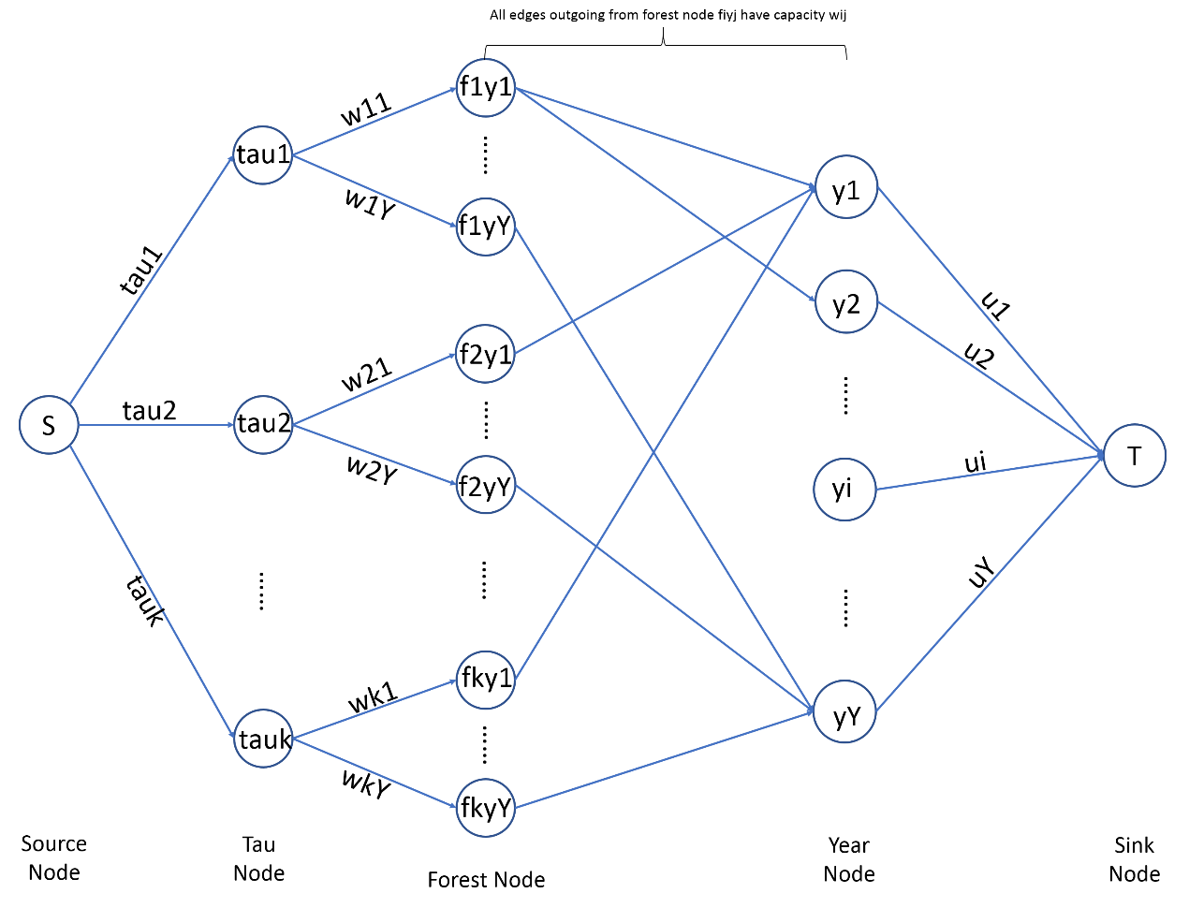

**Note:**

1. In the flow network above, S is the source, and T is the sink.
2. In the flow network above, fiyj stands for node forest i year j.
3. All edges outgoing from forest node fiyj has capacity wi,j.
4. All the trees matured in the Year j can only be sold during Year j to Year j + deltaj - 1. Hence, forest nodes fiyj are connected to year node from yj to yj + deltaj - 1.

## 2.2 Argue the correctness of the algorithm

**Note**: The following theorem and properties will be used.

Integrality Theorem: If all capacities are integers, then there exists a max flow f for which every flow value f(e) is an integer.

Capacity Property of S-T flow: The flow value through edge e will not exceed the capacity of edge e and will greater than or equal to zero, i.e. 0≤f(e)≤c(e).

Conservation Property of S-T flow: For all nodes v except source node and sink node, the total value of incoming flows is equal to the total value of outgoing flows.

In the flow network constructed above, firstly, the edge between source node S and tau node taui has capacity taui , which corresponds to the constraint that for each forest i the total number of trees sold in all Y years shouldn’t exceed taui . Secondly, All edges between tau node taui and forest node fiyj and all edges between forest node fiyj and year nodes have capacity wi,j , which correspond to the constraint that at year j, forest i will have wi,j number of trees become matured. Thirdly, all the forest nodes fiyj are connected to year node from yj to y(j + deltaj - 1), which correspond to the constraint that for trees matured in year j, it can only be sold from year j to year (j + deltaj - 1), and fourthly, all edges between year node yi and sink node T have capacity ui , which corresponds to the constraint that for each year i, we can only sell at most ui trees in order to prevent the effect of overselling which will crash the market.

Based on the above demonstration, I will prove the following two things:

1. If f is the value of the max flow then there exists a schedule that sells f Christmas trees.

Since there exists a max flow with value f, and this flow satisfies the capacity property, the conservation property and the Integrality theorem, therefore, this flow is a valid s-t flow and satisfies all tree selling constraints depicted by the capacities of edges in the flow network. Therefore, this flow can be depicted by a tree selling schedule and the flow values of each edges between forest node fiYj and year nodes are the number of trees we need to harvest from forest i at year j and sell in that schedule. Since that flow is the max flow, thus the corresponding selling schedule is the best schedule.

1. If the maximum number of Christmas trees sold is f then there exists a flow of value f.

All the possible flows in this flow network satisfy the capacity property, the conservation property and the Integrality theorem. Since there is a selling schedule which sells maximum f trees, therefore, this schedule must satisfy all constraints, therefore, we can put the selling schedule into the corresponding edges in the flow network to construct a valid flow to depict this schedule. Therefore, there must exist a flow of value f.

Since both A and B holds, the maximum number of Christmas trees that can be sold is equal to the value of the max flow in the flow network.

## 2.3 Prove the upper bound of the time complexity

**Loading the input data**

Loading and storing the value of k and Y requires O(1) + O(1) = O(1) work.

Loading and storing the value of deltai into an array takes O(Y) time since there are Y delta values in total and each storing operation takes O(1) time.

Loading and storing the value of wij into an array takes O(k*Y) time since there are k*Y wij values in total and each storing operation takes O(1) time.

Loading and storing the value of u into an array takes O(Y) time since there are Y u values in total and each storing operation takes O(1) time.

Hence, loading and storing all data requires O(1) + O(Y) + O(k*Y) + O(Y) = O(k*Y) work.

**Building the flow network**

When building the flow network, we need to add Y edges between source node S and each tau node. We need to add k*Y edges between all tau nodes and all wij nodes since there are k forests and Y years in total. We need to add at most k*Y*Y edges between all forest nodes and all year nodes since for each forest node it can connect to at most Y year nodes and there are k*Y forest nodes in total. Finally, we need to add Y edges between all year nodes and the sink node t. Hence in total we need to add Y + k*Y + K*Y*Y + Y edges in total, and each add edge operation requires O(1) work. Therefore, in total building the flow network costs O(k*Y*Y) work.

**Running the Ford-Fulkerson Algorithm**

We assume without proof that the Ford-Fulkerson Algorithm has running time $O(m^{2}logC)$, where *C* is the maximum flow in flow network *G*, in this case, is $min⁡(\sum_{i=1}^{k}{taui , \sum_{j=1}^{Y}{uj}}, \sum_{i=1}^{k}{\sum_{j=1}^{Y}{Wi,j}})$, and *m* is the number of edges in the flow network, in this case, is ${kY}^{2}$. Hence the Ford-Fulkerson Algorithm takes $O({k^{2}Y}^{4}log⁡(min⁡(\sum_{i=1}^{k}{taui , \sum_{j=1}^{Y}{uj}}, \sum_{i=1}^{k}{\sum_{j=1}^{Y}{Wi,j}})))$ time.

Hence, the running time of the whole algorithm requires $O(kY)$ + $O({kY}^{2})$ + $O({k^{2}Y}^{4}log⁡(min⁡(\sum_{i=1}^{k}{taui , \sum_{j=1}^{Y}{uj, \sum_{i=1}^{k}{\sum_{j=1}^{Y}{Wi,j}})))}}$ = $O({k^{2}Y}^{4}log⁡(min⁡(\sum_{i=1}^{k}{taui , \sum_{j=1}^{Y}{uj, \sum_{i=1}^{k}{\sum_{j=1}^{Y}{Wi,j}})))}}$ work.